**Vocabulary Words:**

**XANES:** X-ray Absorption Near Edge Structure (XANES) is a subset of the XAFS, encompassing the pre-edge region through to 50 – 100 eV above the absorption edge**.**

**Unoccupied state:** An energy level which is not occupied by an electron. It can be any quantum allowed state from an atomic orbital (In Carbon the 3s state and beyond are unoccupied) to a state far into the continuum of states for high energy electrons.

**Density of States:** The density of states (DOS) is the number of electronic states per unit volume at a particular energy.

**Exercise:** Find and circle the words hidden in the figure.

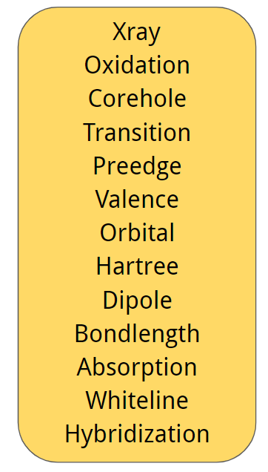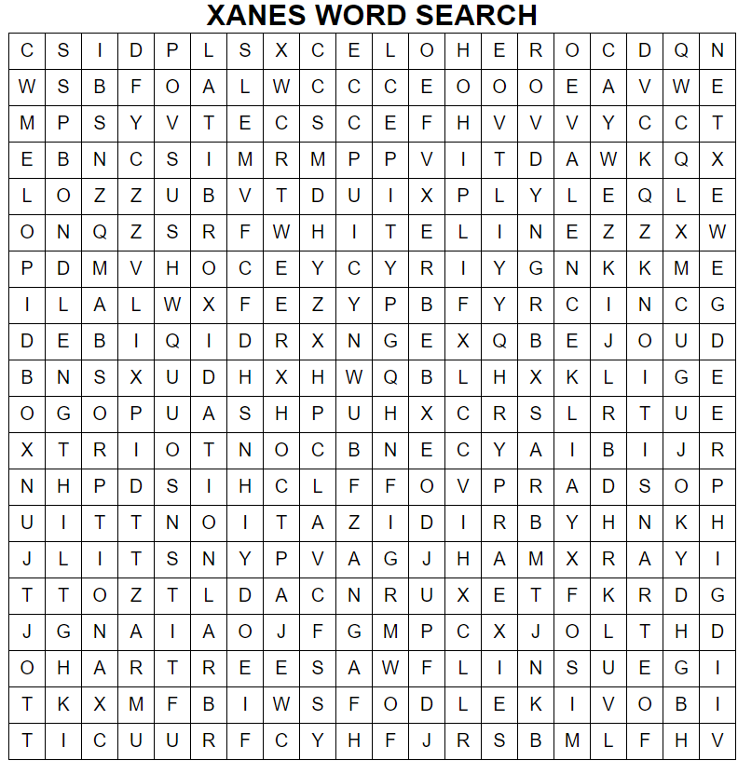

**Exercise:** Given in the table below are the attenuation lengths for pure transition metal samples at 12 keV along with their volume density at STP. For each of these, calculate the cross section $σ = μ/ρ barns per atom$. Match the correct relative farm barn size with the corresponding cross section. Ex: The largest cross section (in units of barns) will correspond to the largest farm barn.

